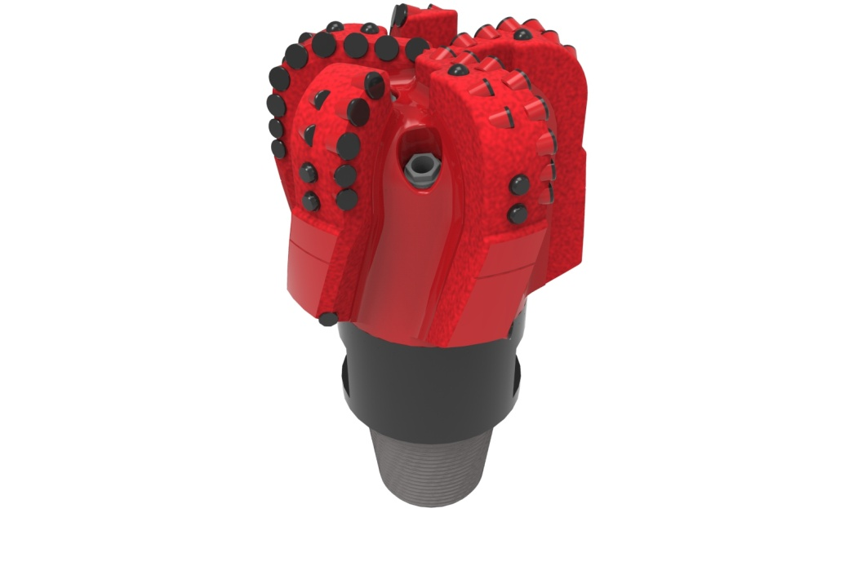
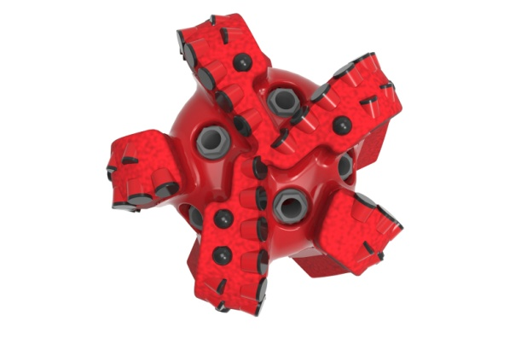

Drill Bit Specifications:
Cutter Size (Primary, Sec) | 5/8”,1/2”
Cutter Count (Total, Gage, Back Ream) | 51,10, 5
Blade Count | 5
Gage Length (Inches) | 3.00
Nozzle Count (Primary, Sec.) | 5
Nozzle Series (Primary, Sec.) | 60
JSA (Sq. Inches) | 19.04
Max. TFA (Sq. Inches) | 1.86
Operating Parameters:
Max. Weight on Bit (1,000 Lbs.) | 60
Make-up Torque (ft/lbs) | 16,488
Nominal Dimensions:
Overall Length (Inches) | 15.55
Make Up Length (Inches) | 11.49
Bit Breaker | SKB-21010
Connection | Ø4-1/2" API Reg.
Approx. Weight (Lbs.) | 110

Standard Features:

- Large open face volume assists cuttings removal
- Seven nozzles optimize blade cleaning and cuttings removal
- Premium grade cutters maximize ROP and Life
- Selectively positioned bullets for smooth drilling
- 1" full gage, 2" tapered gage at 1°

516-XR(K)(BR) Nomenclature Explained:

• | 5 | = | Number of Blades
• | 16 | = | Primary Cutter Size (16mm)
• | XR+ | = | Backup Cutters
• | K | = | Bullets
• | BR | = | Back Reaming Cutters


